Overview/Categorical Dashboard: Lily

Starting with this dashboard, it can be filtered based

on each variable but we find that a customer's location

plays a significant role in their decision to leave the bank.

The majority of our active customers are from Germany,

Spain, and France. However, it is worth noting that the

proportion of churned customers is inversely related to

the population of customers in each location which

suggests a potential problem in areas with fewer

clients, indicating a possible lack of allocated customer service resources.

Moving on to gender distribution, we have,

approximately 54% of the customers are classified as male,

while around 45% are classified as female. Interestingly,

we observe a higher churn rate among female customers,

with 25% of them having churned compared to the churn

rate for male customers which is 16%.

The age of our customers ranges from 18 to 92 but this wide

range suggests that we need to consider the unique needs

and preferences of customers across different age groups.

We found that approximately 56% of customers in the age

range of 50 to 70 yrs old exhibits the highest churn rate.

This age group indicates the need for targeted retention

strategies tailored to customers, however, the distribution

of customer age is right-skewed so there’s relatively

fewer customers in the older age group which means

we need to pay attention to retaining customers

in that specific older age bracket.

**Overview/Categorical Dashboard: Lily**

Starting with this dashboard, it can be filtered based on each variable but we find that a customer's location plays a significant role in their decision to leave the bank. The majority of our active customers are from Germany, Spain, and France. (HOVER OVER THE COUNTRIES IN THE MAP) However, it is worth noting that the proportion of churned customers is inversely related to the population of customers in each location which suggests a potential problem in areas with fewer clients, indicating a possible lack of allocated customer service resources.

Moving on to gender distribution, our customer base consists of approximately 54% male and 45% female customers. Interestingly, we observe a higher churn rate among female customers, with 25% of them having churned compared to the churn rate for male customers which is 16%.

The age of our customers ranges from 18 to 92 but this wide range suggests that we need to consider the unique needs and preferences of customers across different age groups. We found that approximately 56% of customers in the age range of 50 to 70 exhibits the highest churn rate. This age group indicates the need for targeted retention strategies tailored to customers however, the distribution of customer age is right-skewed so there’s relatively fewer customers in the older age group which means we need to pay attention to retaining customers in that specific older age bracket.

Summary

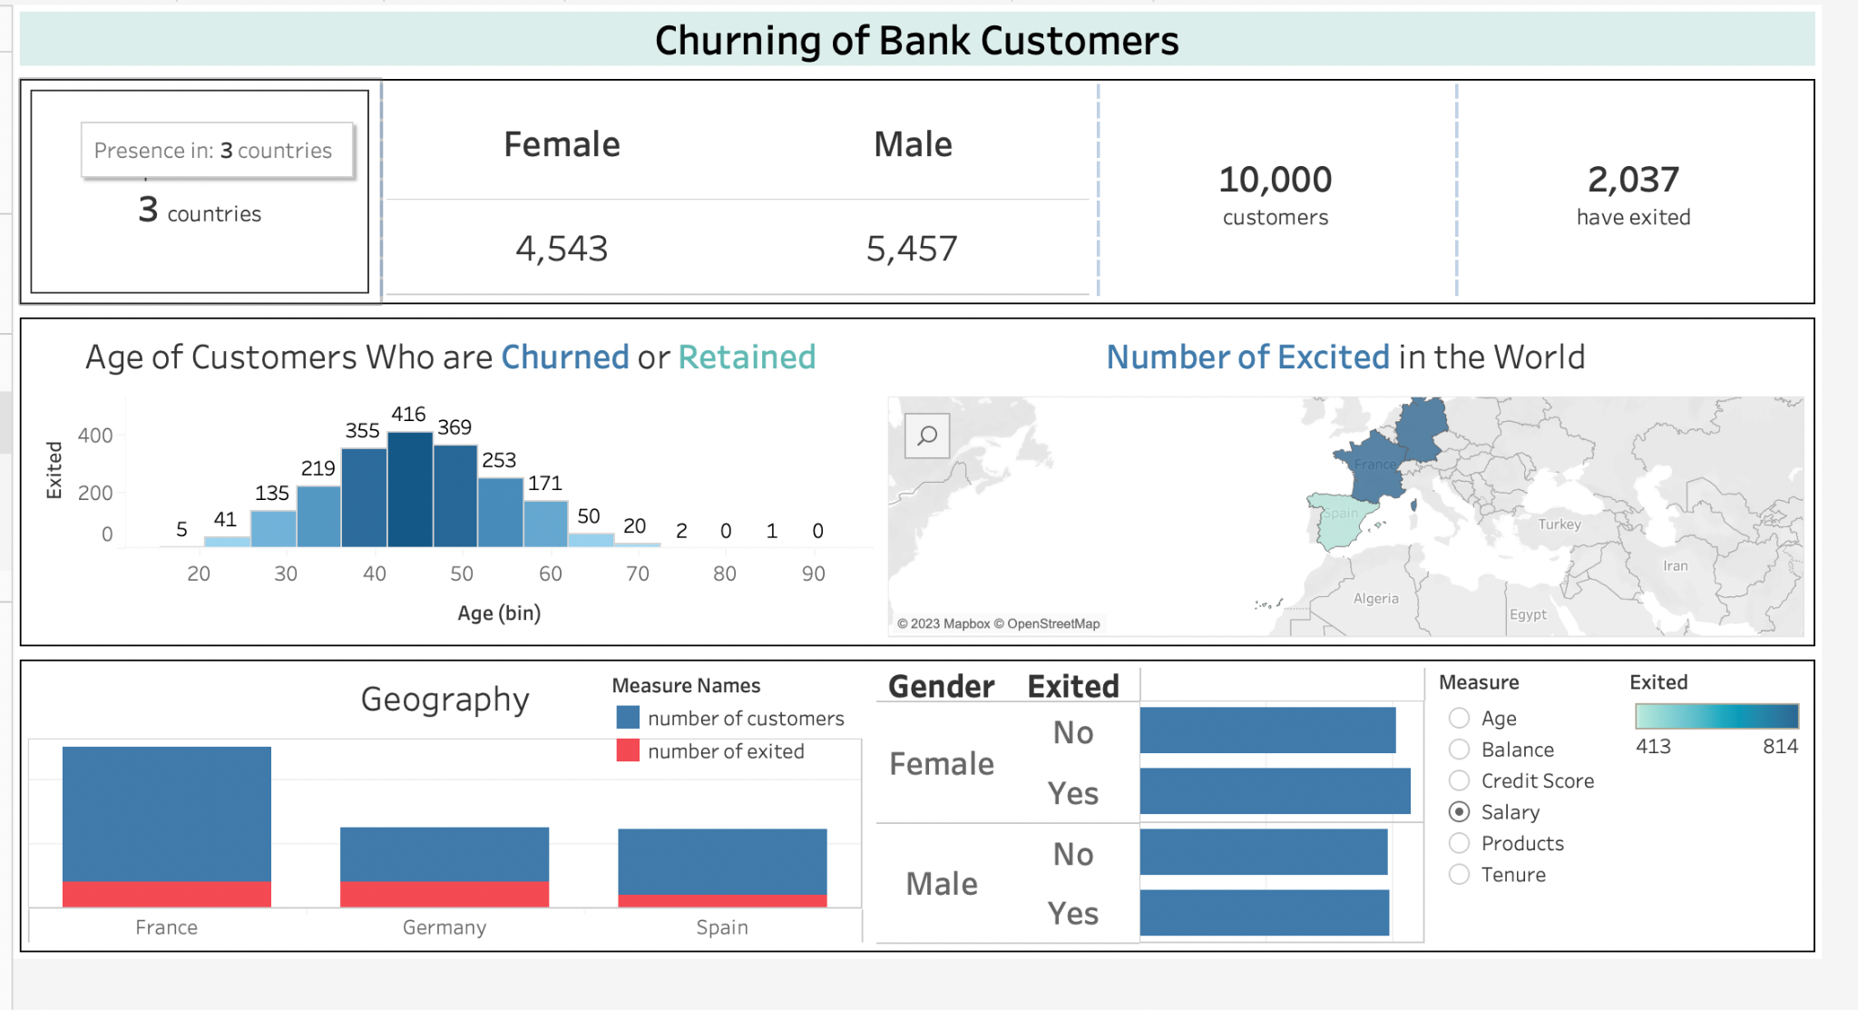

**Overview/Categorical Dashboard: Lily**

Starting with the overview dashboard it provides valuable insights into the variables within our data that are related to customer churn in the banking industry. Within our dashboard, it can be filtered based on each variables but we find that a customer's location plays a significant role in their decision to leave the bank. The majority of our active customers are from Germany, Spain, and France. (HOVER OVER THE COUNTRIES IN THE MAP) However, it is worth noting that the proportion of churned customers is inversely related to the population of customers in each location which suggests a potential problem in areas with fewer clients, indicating a possible lack of allocated customer service resources.

Moving on to customer gender distribution, our customer base consists of approximately 54% male customers and 45% female customers. Interestingly, we observe a higher churn rate among female customers, with 25% of them having churned compared to the churn rate for male customers which is 16%, indicating relatively lower customer attrition in this segment.

The age of our customers ranges from 18 to 92 but this wide range suggests that we need to consider the unique needs and preferences of customers across different age groups. Interestingly, we find that approximately 56% of customers in the age range of 50 to 70s exhibit the highest churn rate. This age group indicates the need for targeted retention strategies tailored to customers in this specific age range. However, the distribution of customer age is right-skewed so there relatively fewer customers in the older age groups which means we need to pay attention to retaining customers in the older age brackets.

The higher churn rate among customers in the age range of 50 to 70s highlights the importance of understanding their specific needs and concerns. It may be beneficial to implement retention strategies such as tailored communication, targeted offers, and personalized support to address their unique requirements. Additionally, expanding our marketing efforts to reach and engage customers in older age groups can help us ensure a balanced customer base and improve customer loyalty across all age ranges.

By analyzing these factors, we can gain insights into potential areas of concern and identify opportunities for improvement.

### Enhancing Customer Loyalty: Strategies for Churn Reduction and Bank Retention

1. **Predictive churn model**: Employ the developed churn prediction model to proactively identify customers with a higher likelihood of churn. Utilize these insights to implement tailored retention strategies that cater to their individual needs and preferences. By leveraging the predictive capabilities of the model, the bank can take proactive measures to retain valuable customers and effectively mitigate churn rates.
2. **Optimize Revenue Potential and customer engagement**: Capitalize on the fact that a majority of customers have 1 or 2 products by identifying opportunities for upselling or cross-selling additional products aligned with their preferences and needs. Strengthen communication channels and engagement strategies to elevate customer satisfaction and foster long-term loyalty.
3. **Customized Customer Engagement:** Deploy personalized retention strategies, placing a particular emphasis on the 50-60 age group. This demographic has demonstrated a comparatively higher churn rate, underscoring the significance of tailoring initiatives specifically towards their needs.
4. **Targeted Resource Allocation:** Based on the data analysis, prioritizing the enhancement of customer service resources in areas with a smaller customer base emerges as a critical imperative. By addressing this challenge, the bank stands to potentially mitigate customer churn and elevate overall levels of customer satisfaction.
5. **Establish a Robust Performance Monitoring System:** Maintain a continuous monitoring process to track churn rates, carefully analyze customer feedback, and assess the efficacy of retention strategies. Leverage data-driven insights to make informed adjustments and enhancements, ensuring the optimization of customer retention efforts and the maximization of overall profitability.
6. **Target Germany for churn reduction**: Recognizing that Germany exhibits the highest churn rate among the analyzed countries, it is essential to undertake targeted initiatives. By delving deeper into the underlying factors driving churn in this specific market, the organization can gain valuable insights to develop and implement effective strategies that effectively mitigate churn.

#### Exited

* Understanding "Exited" offers valuable insights into customer retention:
  + 0 = existing customer
  + 1 = churned customer
* Data Imbalance:
  + dataset is skewed
    - 80% representing existing customers
    - 20% representing churned customers

#### Geography

* Three most popular countries:
  + 50% rep France
  + 25% rep Germany
  + 25% rep Spain
* Churn Analysis:
  + Highest churn rate
    - 32% rep Germany → has the lowest exited rate as well
    - 17% rep Spain
    - 16% rep France

Gender

Summary

Tenure

Summary

Tenure Insights: The duration of customer tenure spans from 0 years to 10 years, with an average tenure of 5 years. This indicates a broad range of customer relationships with the bank.

Concentrated Tenure Range: The majority of customers, approximately 90%, have a tenure ranging from 1 year to 9 years. This suggests a concentration of customer loyalty within this timeframe, highlighting the significance of establishing long-term relationships with clients.

Number of Products

Summary

Product Range: Customers have a varying number of products, typically ranging from 1 to 4. This indicates diversity in the level of engagement with the bank's offerings.

Dominant Product Distribution: An overwhelming majority of customers (approximately 96.7%) possess either 1 product (50.8%) or 2 products (45.9%). This suggests a concentration of customer preferences within this range.

Churned Customers: Notably, all customers with 4 card products have churned, indicating a high likelihood of attrition among this group.

Churn Rates by Product: Among customers with 3 card products, a significant proportion (82%) have churned, highlighting the importance of analyzing product-specific churn patterns.

Has Credit Card

Summary

Credit Card Usage: Approximately 70% of customers possess a credit card, indicating a significant portion of the customer base utilizing this financial product.

Is Active Member

Summary

Active Membership: Approximately 51% of customers are active members, signifying a substantial portion of the customer base engaged in the bank's membership program.

Churn Comparison: Among active members, 14% have churned, while among non-active members, around 27% have churned. This suggests that non-active members have a higher likelihood of churn compared to active members, emphasizing the importance of promoting active membership to enhance customer retention.

Credit Score

Summary

Credit Score Range: The credit scores of customers range from 350 to 850, reflecting the variation in their creditworthiness.

Churned Customers: Notably, all customers with credit scores below 400 have churned. This highlights the significance of credit score as a potential factor contributing to customer attrition, emphasizing the need to address credit-related issues to improve customer retention.

Age

Summary

Age Range: The age of customers spans from 18 to 92, with an average age of around 39. This indicates a diverse customer base in terms of age.

High Churn Rate: Notably, approximately 56% of customers in the age range of 50 to 60 has churned. This age group exhibits a significantly higher churn rate, suggesting the need for targeted retention strategies for customers in this age range.

Age Distribution: The distribution of customer age is right-skewed (positively skewed), indicating that there are relatively fewer customers in older age groups. This skewness suggests the importance of considering age as a potential factor in churn prediction and implementing appropriate measures to retain customers of all age ranges.

Balance

Summary

Zero Balance Accounts: Approximately 36.17% of customers have zero balance in their bank accounts, indicating a significant portion of customers with no funds in their accounts. Out of these customers, 13% have churned.

Balance Distribution: Excluding the customers with zero balance, the distribution of account balances follows a normal distribution pattern. This suggests that the remaining customers, who maintain a positive balance, have a more typical distribution of account balances, enabling the bank to better understand and manage their financial status.

EstimatedSalary

Summary

Estimated Salary Range: The estimated salary of customers ranges from $12 to 200k, indicating a wide variation in income levels among customers.

Balanced Salary Distribution: The distribution of salaries is almost equally spread across this range, suggesting a relatively balanced representation of customers across different income levels. Similarly, the distribution of customer churn is also evenly distributed, indicating that churn is not significantly correlated with salary alone.